APPI Compliance for Log360 Cloud
Strengthen data protection and meet APPI compliance with Log360 .
Region: Japan | Type: Data Privacy | Category: Compliance | Pricing: Free

Overview
The APPI compliance extension in Log360 helps organizations meet the Act on the Protection of Personal Information (APPI), Japan's primary data privacy law enforced by the Personal Information Protection Commission (PPC) by providing centralized log management, access monitoring, and compliance-focused reporting. The platform supports APPI requirements for technical safety controls, access authentication, audit logging, breach notification within 3-5 days, cross-border data transfer monitoring, third-party contractor oversight, and employee supervision across cloud and on-premise environments.
For Security Control of Personal Data, Log360 provides comprehensive SIEM monitoring, real-time alerting, and centralized audit trails to enforce security controls across IT infrastructure. To address Technical Safety Control Measures, the platform monitors access events, detects unauthorized activity, and provides technical security enforcement. The extension also supports Access Control and Authentication Management by providing capabilities that monitors logon events, enforces access policies, tracks privilege escalations, and provides real-time alerting on suspicious authentication.

Key Features
- Audit Logging and Monitoring: Log360 collects, correlates, and analyzes audit logs, providing tamper-proof storage, real-time monitoring dashboards, and compliance reports.
- Data Breach Notification and Incident Reporting: Log360 enables rapid breach detection, incident investigation, and automated compliance reporting workflows.
- Incident Response and Malicious Activity Detection: Log360 provides SIEM-based threat detection, automated incident response workflows, forensic log analysis, and real-time security event correlation.
- Employee Supervision and Personnel Security: Log360 monitors user activity, detects insider threats, and tracks privileged account usage for personnel oversight.

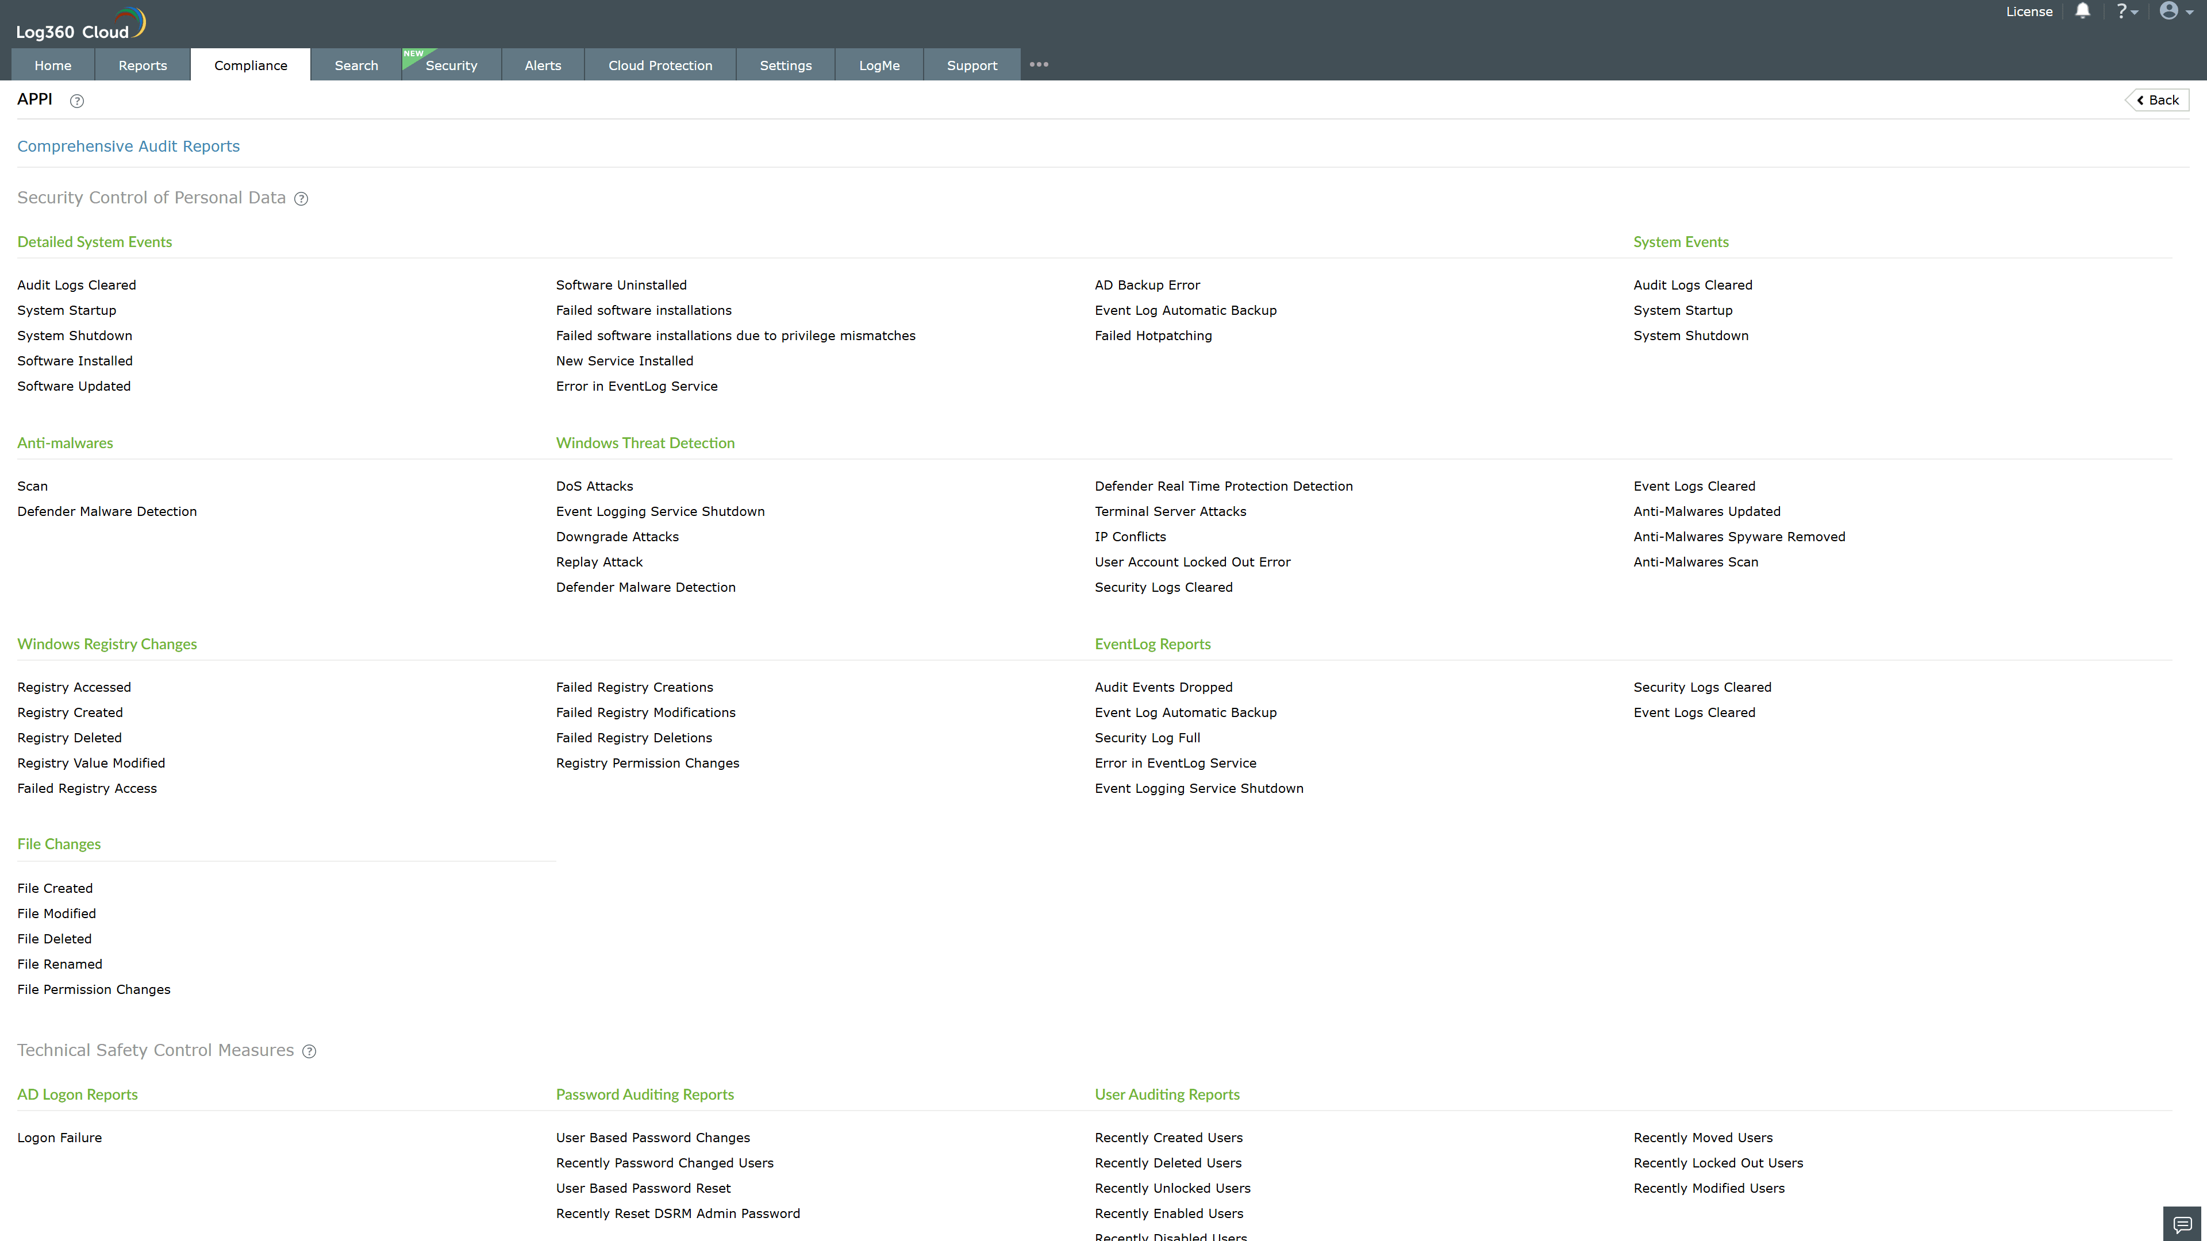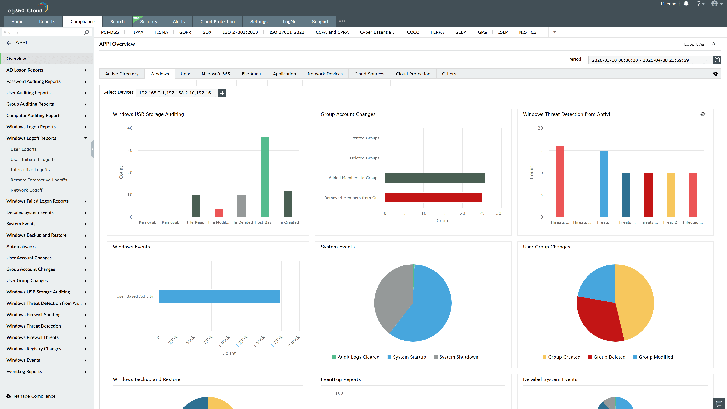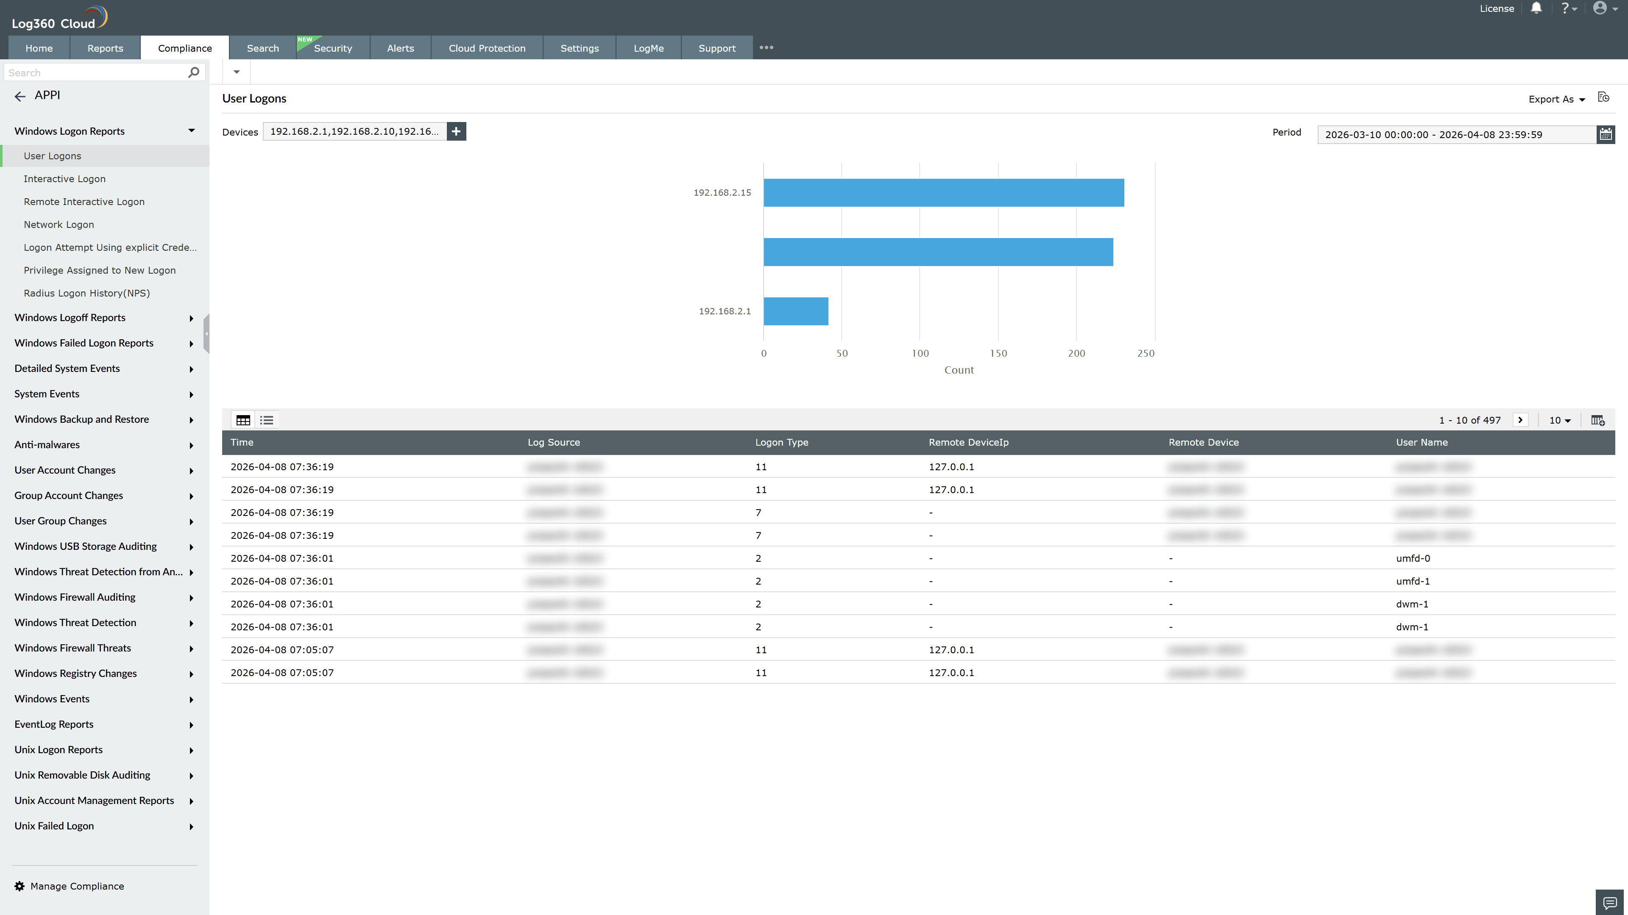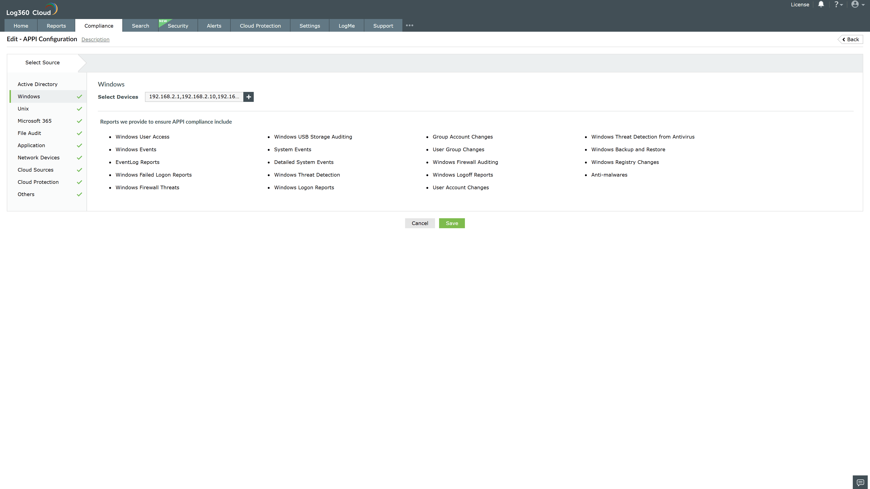

Valid Submission : Yes
Supported Editions : Free, Basic, Standard, Professional, MSSP
Help Document : https://www.manageengine.com/log-management/help/integrations/compliance-extensions.html
Help Video : Not provided
Tags : Log360, Compliance, Privacy monitoring, Data privacy, Regulatory compliance
Supported DCs : US, IN, JP, CA, AU, UK and EU
Privacy Policy:
Terms of Service:
Release Notes:
Predefined reports for the APPI.

